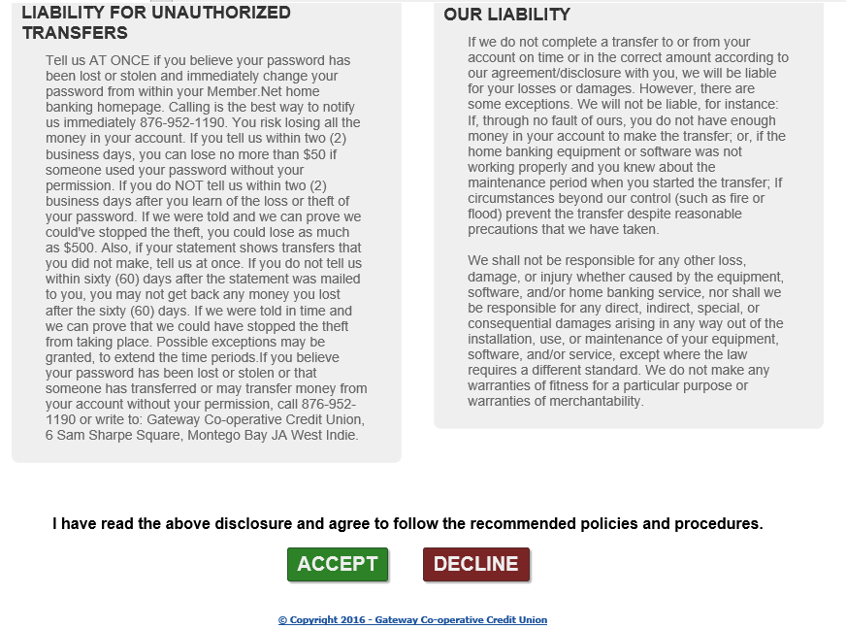

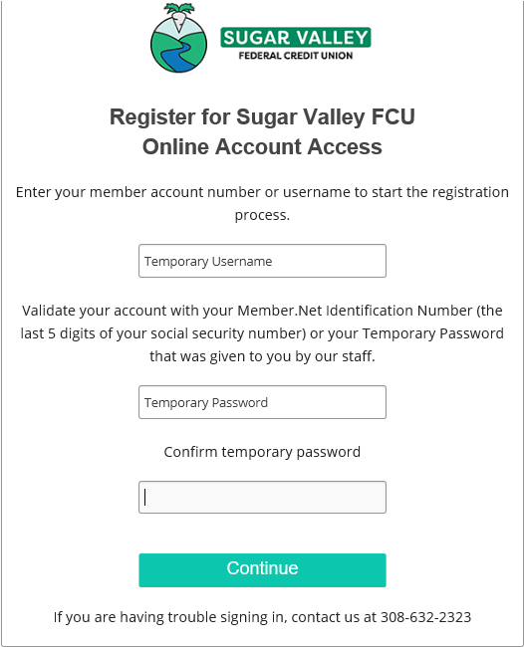

The first time you use our new home banking system, you will need to register your account.

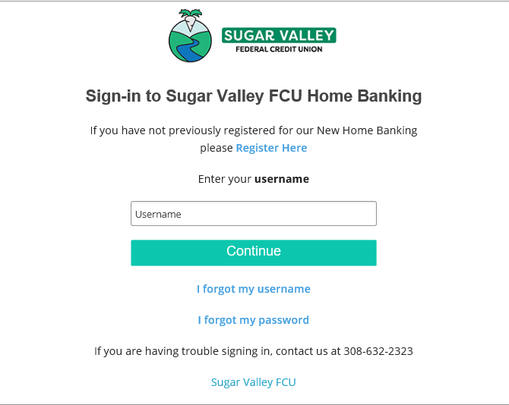

Click accept to the Terms and Agreements.

Enter your temporary username which is your account number.

Enter your temporary password which is the last 5 digits of your SSN.

Enter your account information, username, and password.

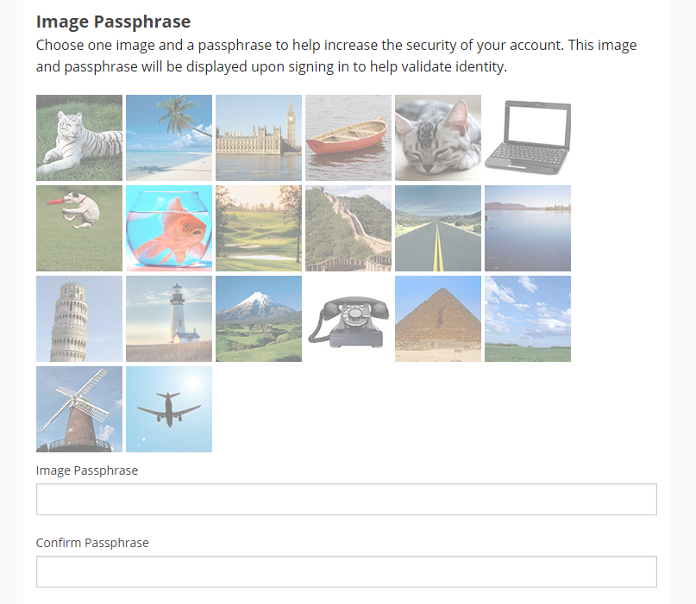

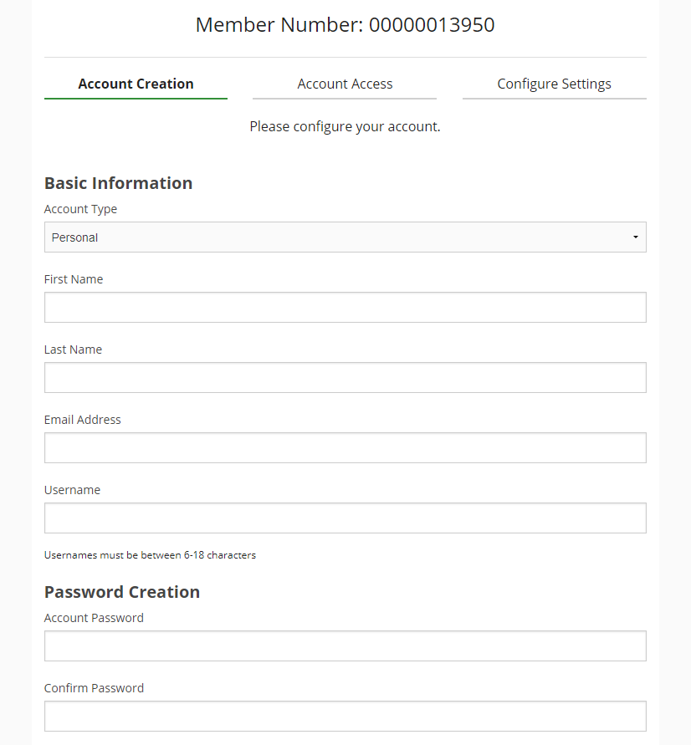

Choose an image and image phrase. Once you enter your username and answer one security question, if your image pops up you can then enter your password.

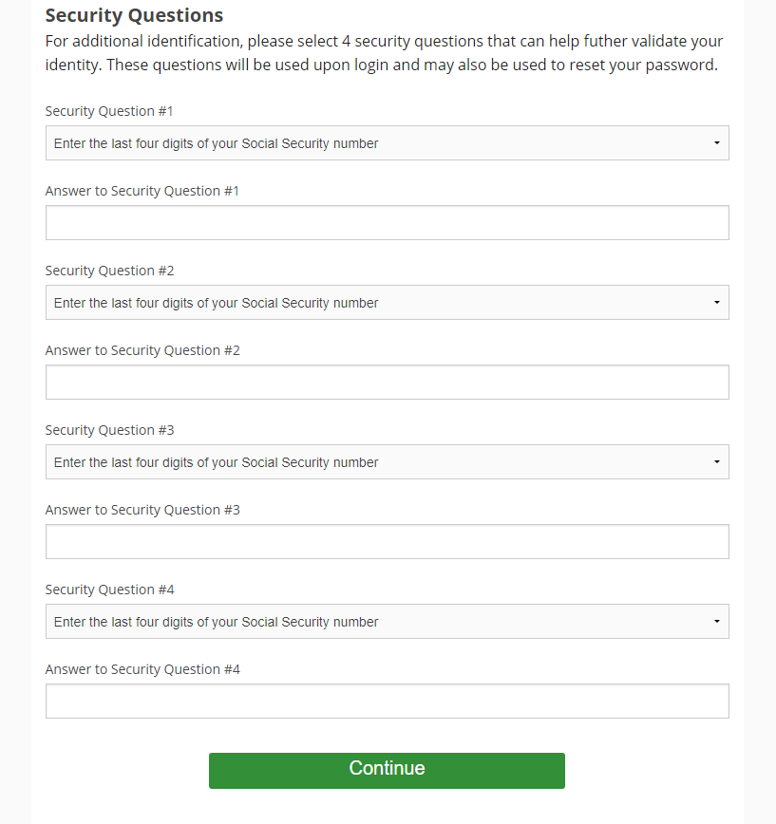

Answer four different security questions. \*The answers are not case sensitive.

Account Alerts can also be used to set a reminder to make loan payments.

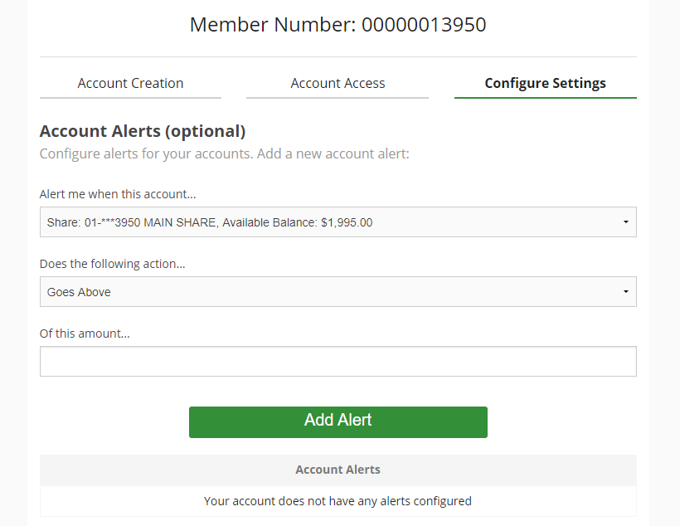

Linked accounts are related accounts that the member is attached to and can transfer money to and from.

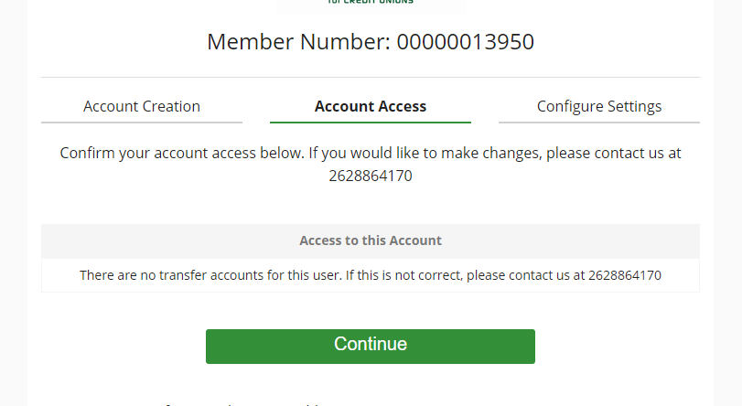

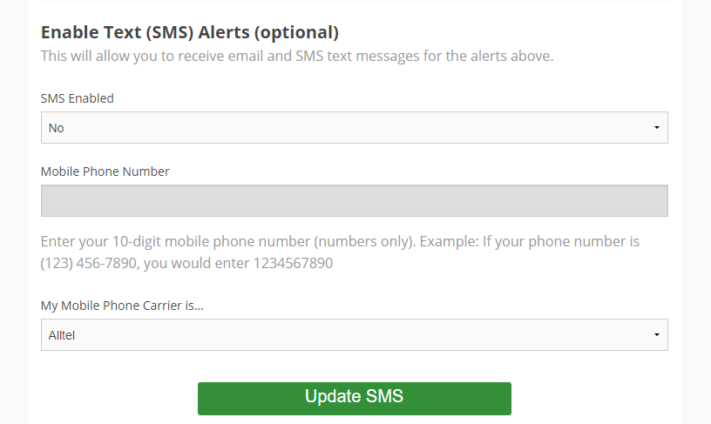

\*\*E-statements start from registration.

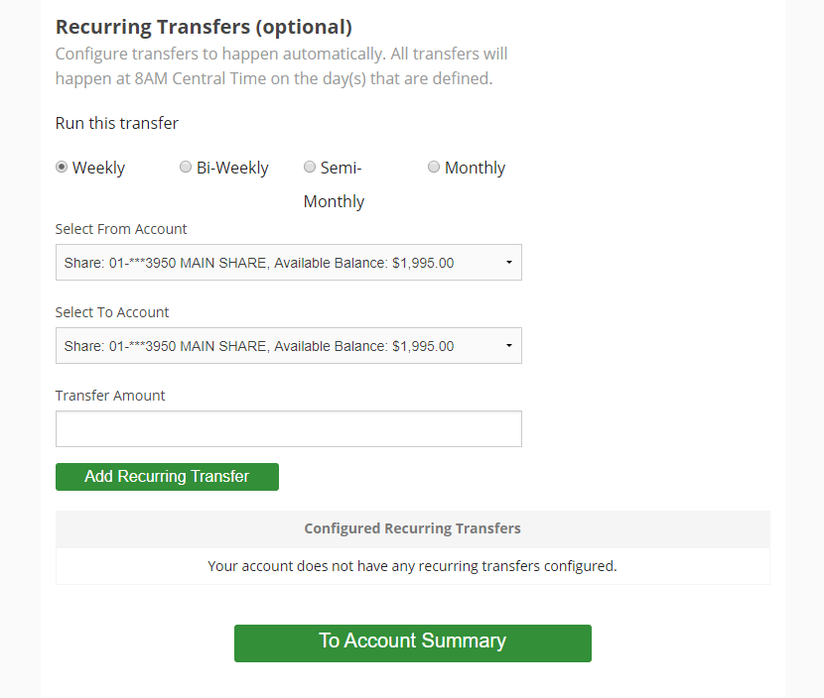

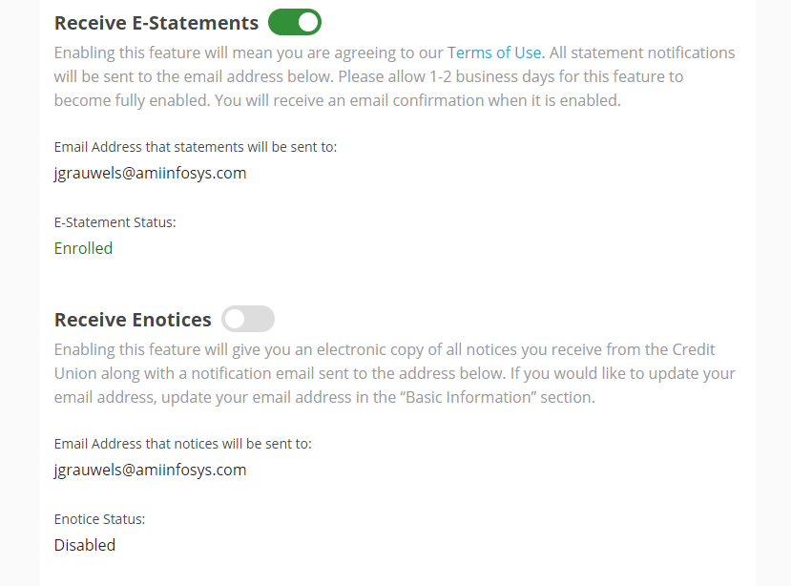

Receipts, OD Notices, Certificate Notices, Delinquent Notices…

\*\*You can go to your settings anytime to make changes or enable text alerts, signup for E- statements or notices, and/or set recurring transfers.

After logging in, you will be taken to the Member.Net Live homepage. From here, you can check the balances of shares, drafts, certificates, and loans. You can also view transaction history and make transfers.